

Terminal Operation System

IT Operations Procedures

Table of Contents
1. Sign-off 4
2. Revision History 5
3. Document Purpose 7
4. System Data Flow Diagram 8
5. Description of the Application 9
5.1. Current Terminal Operation System 9
5.2. Future 11
6. Application/Instance Setup Procedures 13
6.1. Web Server Setup 13
6.2. Unix Setup 14
6.3. Database Setup 14
6.4. WebLogic Setup 14
7. Application Start/Stop Instructions 37
7.1. Weblogic 37
8. Configuration Files 38
9. Dependencies 39
10. Jobs, Schedule and Messages/Alerts 41
11. Health Checks 47
12. Exception Handling 49
13. Users 50
14. Alarming Requirements 52
14.1. Process Name 53
14.2. System 53
14.3. Error Log 54
14.4. Log Message 54
14.5. Description 55
14.6. Action 55
14.7. Additional Notes 55
15. DASD Purge 58
16. List of All Data Files and Their Definitions 58
17. Maintenance Windows 58
18. Reports/Output 59
19. Support Escalation Process and Contact Details 60
20. Post Production Monitoring and Metrics 61
21. Manual Test Procedures 61
22. Roles and Responsibilities 62
23. Appendix 62
23.1. XPS Server Setup 62

- Sign-off
Use the following matrix for obtaining sign-off on each document. Insert the role name in the table below for each person responsible for sign-off on this particular template, and indicate in this section of the template exactly what the sign-off represents.
Name | Role | Date | Signature
Marwan Aiche | Development Manager
Cindy Kowell | Production Operations Sr. Mgr.

- Revision History
For each revision of a document, please log the major changes made for that version.
Document Revision History
Date | Version | Page(s) | Change Control # (optional) | Description | Author(s)
4/19/07 | 0.1 |  |  | Initial version | John Feng
11/13/07 | 0.1 |  |  | Added WLS setup | John Feng
01/08/08 | 0.1 |  |  | Add tos.ear deployment | John Feng
07/07/08 | 0.1 | 11 |  | Added Queues for ALL Locations. Only Batch Queue for HON. | Steven Bauer
07/14/08 | 0.1 | 7 |  | Updated Weblogic deployment with cluster information and coherence cache configuration. | Steven Bauer
7/15/08 | 0.2 | 15 |  | Updated cache procedure | Steven Bauer
7/31/08 | 0.2 |  |  |  | Steven Bauer
8/21/08 to 9/12/08 | 0.3 | All |  | Updated WebLogic startup procedures, alarming requirements, user list, table of contents, sign off required, FTP proxy IDs required, automated jobs, etc. | Christopher Bailey
9/30/08 to 10/15/08 | 0.4 | All |  | After the move to preproduction, a number of items on the install were ironed out | Christopher Bailey
11/8/08 | 1.0 | 16, 34 |  | New user setup in WebLogic security realm. Updated WebLogic Startup instructions when there is a new version of apex.war. | Christopher Bailey
11/11/08 | 1.0 |  |  | Changed the startup script from managed server to weblogic server startup. | Christopher Bailey
11/08/08 | 1.0 |  |  | Added the Navis license file to the deployment procedure. | Christopher Bailey
2/27/09 | 1.0 |  |  | Example email alert updated. Subject now includes the environment and server of the error. | Christopher Bailey
3/11/9 | 1.0 |  |  | Max connection pool size for the APEX data source | Christopher Bailey
4/9/9 | 1.0 |  |  | Updated the XPS server procedures to reference the WIKI site. Updated the Logical view because the Gate PCs and Edge Manager do go through iPlanet. | Christopher Bailey
4/28/9 | 1.0 | 8, 11, 12, insert 15, insert 25, 43, 58 |  | Added an interface from TDP to HDOA (State of Hawaii’s Department of Agriculture). | Christopher Bailey
5/20/9 | 1.0 | 16, 39, 42, 59, 60 |  | Input from Sandy Wong | Christopher Bailey
5/21/9 | 1.0 | 13, 41, 59 |  | Input from Sandy Wong | Christopher Bailey
5/22/9 | 1.0 | 42, 43 |  | Invasive species updates related to outages and timings. | Christopher Bailey
5/27/9 | 1.0 | 15, 32, 60, 61 |  | Invasive species IP updates. DR updates. | Christopher Bailey
8/21/09 | 1.0 | 14 |  | Added archive of the CMIS feed logs | Steven Bauer
9/30/09 | 1.0 | 14 |  | Added weblogic hostname mapping | Steven Bauer
08/06/10 | 1.0 | 14 |  | Listen Address dependant Config changes on unix setup host file For the TOS application to consume messages off the N4 queue. | Glenn Raposo
08/16/10 | 1.0 | 58 |  | Updated PP and Prod Sparcs Database IP’s to the X86 Database | Glenn Raposo
08/17/10 | 1.0 | 35 |  | Updated MQ config setup for each environment | Glenn Raposo
08/17/10 | 1.0 | 40 |  | Added N4Event and Newves Topic and its Subscribers | Glenn Raposo
08/17/10 | 1.0 | 40 |  | Added Gems Queue | Glenn Raposo
08/19/10 | 1.0 | 21 |  | Adding Edge Manager user. One user for each gate. As now each gate has its own workflow on the edge manager side. | Glenn Raposo
10/05/10 | 1.0 | 31 |  | Added FTP Mapping for Cmis Area To pickup VPU,VPS and NIT action | Glenn Raposo
08

- Document Purpose
The purpose of this document is to provide a reference point for the Operations group to maintain the Terminal Operation System.

- System Data Flow Diagram
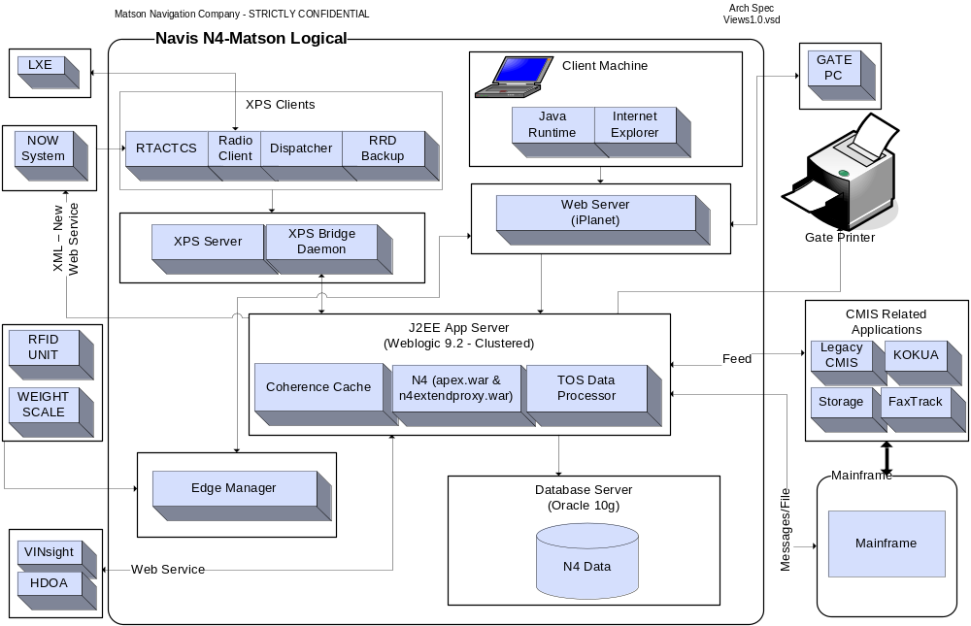
- Description of the Application
Additional documentation can be found on the WIKI, in the TOS category.
  - Current Terminal Operation System
Matson uses a legacy Terminal Operation System known as CMIS in Honolulu at the Sand Island and Pier 29 ports.
Container Management Information System (CMIS) was developed in 1988 using Borland’s Paradox for DOS. Paradox is a flat file database with relational capabilities which are not really utilized by the CMIS application. Instead logic is implemented using the Paradox Application Language (PAL) to manage data and enforce rules within the application.
The CMIS data model centers around two tables, the container table and the OUTQUE table. The container table represents active containers present at the port at anytime. A transaction to load/discharge a container to/from a vessel, send it out of the gate or even just to edit its status is immediately reflected in the container table. The OUTQUE is a workflow table that records instructions from these transactions for processing by backend processes that translate these instructions according to the business rules and propagate them to other tables for reporting, KOKUA (customer) and audit history. Applications like Storage & Detention, Chassis License, Faxtrack and KOKUA use these tables directly. The information may propagate to third party vendors like Young Brothers to complete the route for Matson. Other sub-systems also feed from CMIS and this is not a conclusive list.
SPARCS is a software product provided by the software provider, Navis. While the main function of CMIS is to handle the gate and corrective, administrative actions, the main function of SPARCS is the yard and vessel automation. SPARCS today integrates with NOW and as well LXE’s in the yard to perform transactions such as loading and unloading containers from the ship.
When a vessel leaves a west coast port, destined to Hawaii, a CMIS module called “New Vessel” is initiated with the following four main inputs:
- RDS (from FACTS)
- Stow Plan (from ACETS)
- STIF File (Mainsail or SPARCS)
- Dangerous Cargo Manifest a.k.a. DCM (Mainsail or CMIS)

Output from this process is delivered to SPARCS today. This input to SPARCS allows for planning.

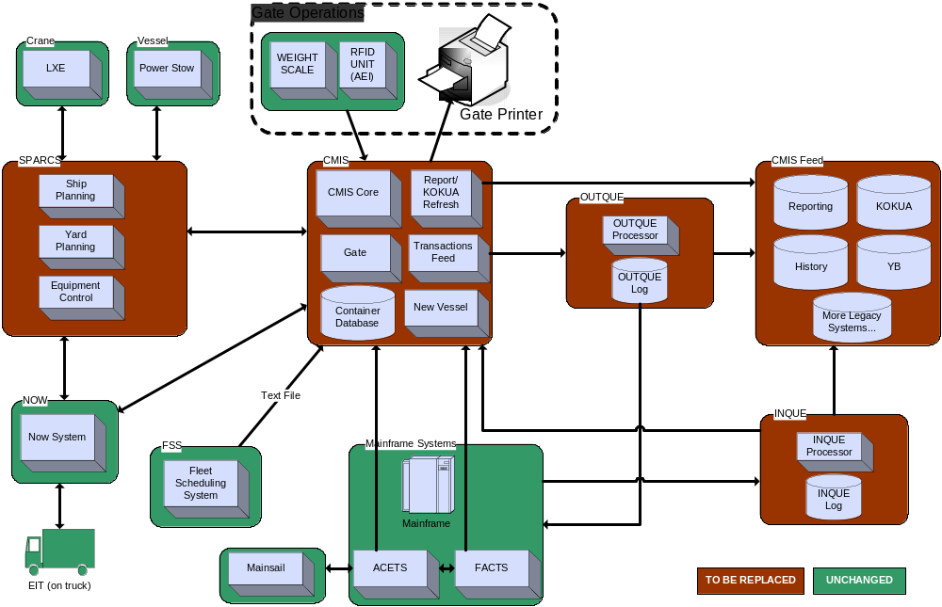
  - Future
The objective of this project is to replace CMIS with a new Terminal Operating System (N4 from Navis) which is based on distributed architecture with a Web-based front end, Application Tier and Relational Database. The introduction of N4 will require a SPARCS upgrade that will include a new server, referred to as XPS. The project will also require new Matson integration software. This integration software will allow communication between N4/SPARCS and ACETS/FACTS/Fleet Scheduling System and other internal Matson systems. The integration software will run on our target architecture, utilizing common components.
Eliminating CMIS completely will not happen during the first deployment. Until all components of CMIS can be replaced, there will be a legacy version of CMIS running. For example, when N4 is deployed to Sand Island, CMIS will still be used by other neighbor islands. Kokua, reports, and other sub-systems will remain in legacy CMIS until they are replaced.
One of the external interfaces is the State of Hawaii’s Department of Agriculture (HDOA). The HDOA requires a manifest from Matson for vessel’s arriving in Hawaii. This requirement stems from recent laws within the state regarding invasive species. Matson accomplishes this with an automatic feed from TDP to the HDOA using web services.

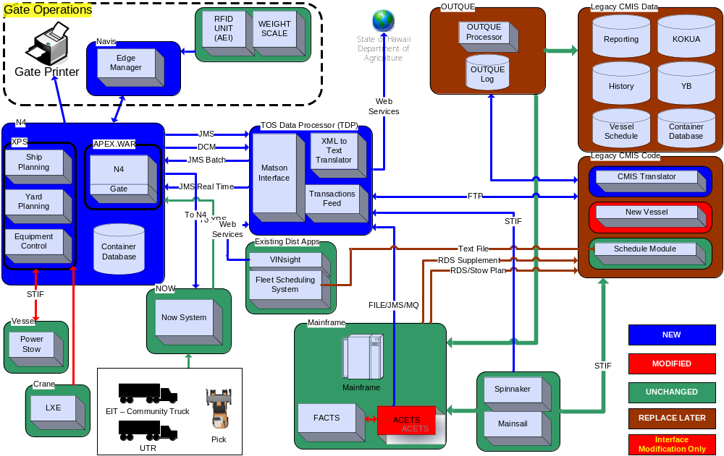
http://wiki.matson.com/index.php?title=Image:Terminal_Operating_System_Future_State_Overview.png
- Application/Instance Setup Procedures
  - Web Server Setup
Navis SN4 is a web application and there are two other web applications in tos.ear. We need to config web server for the URLs.

    - The application will be a Matson distributed application with a provided security layer that includes SSL. No other communication to the outside network using EDI or similar will be required.
    - The application may be available to people outside of Matson network. There are outside users from Pacific Transporation Lines and Norton Lilly that will use the application. These users will be able to access the application through SSL and with valid credentials.

The web server setup for iPlanet should have the following entries:

<Object name="load balance Navis" ppath="*/apex/*"> Service fn="wl-proxy" WebLogicCluster="10.201.0.14:9302, 10.201.0.14:9301" WLLogFile="/wh/iplanetws/https-www.matson.com-
https-443/logs/tos_navis.log" Debug="OFF"
</Object>

<Object name="refdata" ppath="*/refdata/*">
Service fn="set-variable" remove-headers="Expect: 100-continue"
Service fn="wl-proxy" WebLogicHost="10.201.0.14" WebLogicPort="9301" WLLogFile="/wh/iplanetws/https-www.matson.com-
https-443/logs/tos_refdata.log" Debug="OFF"
</Object>

<Object name="refdata" ppath="*/tos/*">
Service fn="set-variable" remove-headers="Expect: 100-continue"
Service fn="wl-proxy" WebLogicHost="10.201.0.14" WebLogicPort="9301" WLLogFile="/wh/iplanetws/https-www.matson.com-
https-443/logs/tos_tdp.log" Debug="OFF"
</Object>

Use the following IP addresses & port numbers when making the above additions.
Environment | IP Address:Port | IP Address
QA | 10.201.0.14:9301  10.201.0.14:9302 | 10.201.0.14
PRE-PROD | 10.201.2.27:9301  10.201.2.29:9401 | 10.201.2.27  10.201.2.29
PRODUCTION | 10.201.1.18:9301  10.201.1.21:9401 | 10.201.1.18  10.201.1.21

  - Unix Setup
On the physical box running the WebLogic software there are some setup items required.
- Log file directories need to be created and read/writable by the user that starts the WebLogic process.
  - /home/logs/applogs/TOS
  - /home/logs/applogs/cas
  - /home/logs/applogs/TOS/ftp

Files in /home/logs/applogs/cas need to be deleted so they don’t take up to much space. Delete all the .TXT files older than 30 days using a cron job.

- On the Unix server, make sure the following line is in the /etc/hosts file and the “localhost” is assigned to only one IP address.
  - “127.0.0.1 localhost”
- On the Unix server, copy the “navis-license.xml” file to the DOMAIN_HOME directory (typically /home/weblogic/bea921/user_projects/domains/MATSON). This file is the same in all environments and exists today in DEV.

The infrastructure team should allow outbound traffic from the WebLogic servers to HDOA.
Environment | Matson Originating IP Address | HDOA IP Address | HDOA Port
DEV | 10.3.4.179 | 64.129.8.55 | 20100
QA | 10.201.0.14 | 64.129.8.55 | 20100
PRE-PROD | 10.201.2.27  10.201.2.29 | 64.129.8.55 | 20100
PRODUCTION | 10.201.1.18  10.201.1.21 | 64.129.8.55 | 20200

Here is the documentation from HDOA:

From: Louie Ramones [mailto:LouieRamones@decisionresearch.com]
Sent: Thursday, April 02, 2009 2:12 PM
To: Amit Asija at HQ x4203; Lorna Lee; John Agsalud; Chris Bailey at PHX x5256
Cc: Duane Char; Jocelyn Chagami at HON x8317; Bob Matthews at HQ x4228
Subject: RE: Manifest Web Service is available, latest schema

Hi Amit,

Per our discussion, here is the info your network dept may need. I have temporarily allowed any IP to access the web service so you can work offsite today. However, I will lock it down to Matson’s network by the end of today. If your network department has any questions or need me for testing, they can reach me at (808)983-9135. Thanks.

20100 – Test Port
20200 – Production Port
64.129.8.36 – Our outgoing IP address
64.129.8.55 – Webservice IP

- Configure /etc/host with mapping for weblogic1, weblogic 2, weblogic 3
Add this line to the /etc/host:

Environment | Line
DEV | 10.8.7.145 unx08d1s weblogic1 weblogic2 weblogic3
QA | 10.201.0.6 matcamuqa08 weblogic1 weblogic2 weblogic3
PREPROD | 10.201.2.6 matcvauaa16 weblogic1 weblogic2 weblogic3
PROD | 10.201.1.4 matcamupa03 weblogic1 weblogic2 weblogic3

5. Configure /etc/host with mapping for tosJmsServer

Listen Address Config change on WL-Admin Server1 & 2 for node2 Jms server issue: Dependant change need for the existing tos.ear application to consume messages out of the N4 out queue.
Environment | Line
DEV | 10.3.4.179 ohquda02 tosJmsServer
QA | 10.201.0.14 matcamuqa35 tosJmsServer
PREPROD | 10.201.2.27 matcvauaa37 tosJmsServer
PROD | 10.201.1.18 matcamupa41 tosJmsServer

From: Glenn Raposo at HON x1243
Sent: Friday, August 06, 2010 12:51 PM
To: Bill Cheung at HQ x4260; Sulo Wijetunga at HQ x4387; 1IT OPS Support at HQ
Cc: 1TOS Dev Team at HON
Subject: TOS : Change Request for Listen Address Config change on WL-Admin Server1 & 2

Bill,
We would need an environment variable(tosJmsServer) set in each environment (Dev, QA, PP, Prod) for the listen address change to work with our application(tos.ear). Could you create a tickets to roll this changeover. IP addresses below are environmental specific JMS server installed IP’s.

Reason: The application(tos.ear) binding/config file use localhost as the listen address to read off the queue. I missed out this one config in my first analysis causing nothing to read off N4 out queue.

TOS Dev team Work effort: a) Code change in tos.ear b) deployment & Testing QA, PP, Prod

  - Database Setup
Database setup for the TOSMGR schema is required before deploying the Navis, apex.war file. The database team simply needs to setup the schema and users. The application will access the database through the “jdbc.ds.apex.nontx” data source.
Database setup and population of the tables is needed before deploying the TOS Data Processor application. The database schema is TOSCSTMMGR which will be accessed through WebLogic data source TOS_CSTM_DS. The DBA will setup TOSCSTMMGR and TOSCSTMUSER users in the schema and associated tables. Initialization scripts should be run – see the appendix.
  - WebLogic Setup
According to the architecture specification, each environment will consist of two managed servers in a cluster and an administration server.
The Navis application is called N4 and the deployment artifact is “apex.war”. This deployment should be targeted to the cluster.
A Matson application called TOS Data Processor is integration software used to communicate between the new N4 system and legacy applications. The deployment artifact is called “tos.ear” and should be deployed to a single managed server [DEV= SVR1_A02_DEV, QA= APP_35a_QA, PP= APP_37a_PRE, PROD= APP_41a_PROD].
Domain Configuration Changes
Ensure that the server’s listen address is not set (left blank). You can see this on the WebLogic Admin Console:
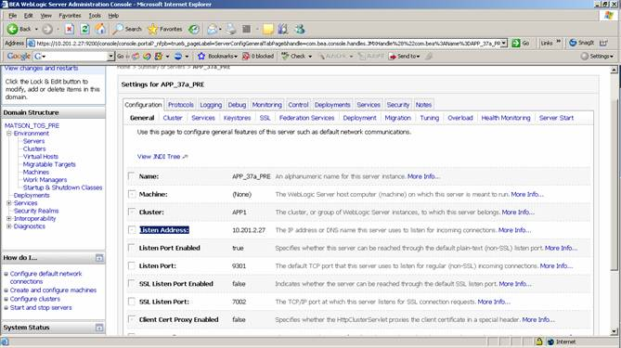

Security Realm Changes
The edge manager server that runs in Honolulu and gathers RFID reads to transmit to N4 requires a user in the WebLogic security realm, under the default authenticator. No groups are required. User=”edgemang”, Password=”edgemanager”.
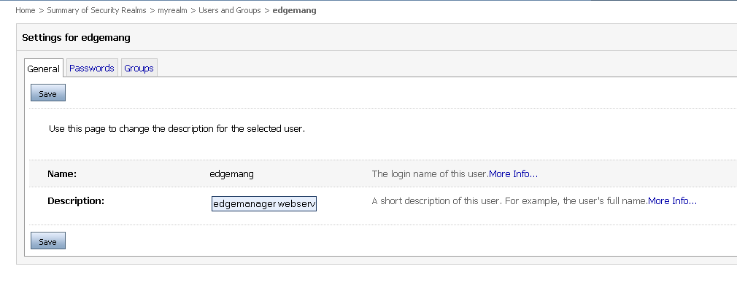

Adding Edge manager Users –
Edge manager users have the same ID and password and no group required. This change has been made to spereate Edge manager gate workflows to each gate.
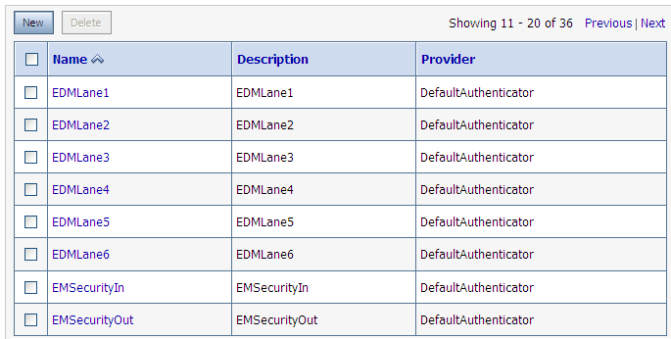
Startup Script Changes
Put MQ jars files in classpath of WebLogic.
PATH="${PATH}${PATHSEP}/opt/mqm/java/bin${PATHSEP}${DOMAIN_HOME}/lib"

CLASSPATH="${CLASSPATH}${CLASSPATHSEP}${MEDREC_WEBLOGIC_CLASSPATH}"
CLASSPATH="${CLASSPATH}${CLASSPATHSEP}${DOMAIN_HOME}/lib/com.ibm.mq.jar"
CLASSPATH="${CLASSPATH}${CLASSPATHSEP}${DOMAIN_HOME}/lib/com.ibm.mqjms.jar"
CLASSPATH="${CLASSPATH}${CLASSPATHSEP}${DOMAIN_HOME}/lib/providerutil.jar"

Update the Java Options in the weblogic server start up script (start_Weblogic.sh) by adding the following to the java options.
-Dweblogic.name=server name
-Dweblogic.Name=server name
-Dweblogic.log.dir=/home/logs/applogs/TOS
-Dtangosol.coherence.extend.enabled=true
-Dtangosol.coherence.extend.port=port number
-Dtangosol.coherence.extend.enabled=true
-Dtangosol.coherence.extend.address=server ip address
-Dtangosol.coherence.localhost= server ip address
-Dtangosol.coherence.extend.localhost= server ip address

Use the following port numbers & server names when making the above additions.
Environment | Hostname &  IP Address | Managed Server Name | Port to use in option above
DEV | Ohquda02  10.3.4.179 | SVR1_A02_DEV  SVR2_A02_DEV | 15151  15152
QA | MATCAMUQA35  10.201.0.14 | APP_35a_QA  APP_35b_QA | 15151  15152
PRE-PROD | MATCVAUAA37  10.201.2.27  MATCVAUAA38  10.201.2.29 | APP_37a_PRE  APP_38a_PRE | 15151  15152
PRODUCTION | MATCAMUPA41  10.201.1.18  MATCAMUPA42  10.201.1.21 | APP_41a_PROD  APP_42a_PROD | 15151  15152

This will require the port be passed from the individual server startup scripts. Specific instructions to setup this startup follow. In ${DOMAIN_PATH}/bin edit the following files with the following changes.
Add to:  startManagedWebLogic.sh | #set Navis N4 java options  JAVA_OPTIONS="${JAVA_OPTIONS} -Dtangosol.coherence.clusteraddress=cluster_address -Dtangosol.coherence.extend.enabled=true -Dtangosol.coherence.extend.port=${COHERENCE_PORT}" -Dtangosol.coherence.extend.address=server ip address -Dtangosol.coherence.localhost= server ip address -Dtangosol.coherence.extend.localhost= server ip address
Remove from:  startWebLogic.sh | JAVA_OPTIONS="${JAVA_OPTIONS} -Dtangosol.coherence.clusteraddress= cluster_address "
Add to:  start_SVR1_A02_DEV.sh | COHERENCE_PORT=15151  export COHERENCE_PORT
Add to:  start_SVR2_A02_DEV.sh | COHERENCE_PORT=15152  export COHERENCE_PORT

Data Source Setup
** All passwords provided by the DBA team.
1. Data Source for Navis, APEX.WAR deployment.
Data Source Name | jdbc.ds.apex.nontx
JNDI Name | jdbc/apexDS
Target | Cluster
Test Connections on Reserve | True
Maximum Capacity | 65
Development Environment
URL | jdbc:oracle:thin:@10.3.4.180:1521:tosd01
Driver | oracle.jdbc.OracleDriver
Properties | user=tosmgr
QA Environment
URL | jdbc:oracle:thin:@10.201.1.8:1521:MATQ03
Driver | oracle.jdbc.OracleDriver
Properties | user=tosmgr
PreProduction Environment
URL | jdbc:oracle:thin:@10.201.2.15:1521: MATA03
Driver | Oracle.jdbc.OracleDriver
Properties | user=tosmgr
Production Environment
URL | jdbc:oracle:thin:@10.201.1.9:1521: MATP03
Driver | oracle.jdbc.OracleDriver
Properties | user=tosmgr

Max connection size is based on a recommendation from Navis:

From: Seiler, Peter [mailto:pseiler@navis.com]
Sent: Friday, March 13, 2009 2:29 PM
To: Chris Bailey at PHX x5256; Steven Bauer at PHX x5274
Cc: Jocelyn Chagami at HON x8317; Marshall Dailey at PHX x5259; Clason, Andy
Subject: Solution for case 61841 (Connection Pool Exception)

Chris, Steve,

Our research has uncovered the source of the Oracle Connection Pool problem you encountered.

The JMS queue is single-threaded and will only use one connection at a time. However, each update triggers event notifications which do updates or invoke Groovy code that does updates, those, in turn, trigger more updates that trigger more event notification … Each event notification in the ‘water fall’ of updates and notifications runs on its owe thread. There are 25 threads available for event notifications.

In addition there are 25 threads for ULC UI updates (triggered by user clicks).

Add to that XPS updates (4 threads), Edge Manager API calls, EDI posting, background jobs … .

We recommend that Matson set the Weblogic Maximum Capacity of the connection pool for ‘jdbc/apexDS’ to 65.

Peter Seiler
Navis, LLC
1000 Broadway, Oakland, CA 94607
Phone: +1-510-267-5474
2. Data Source for the TOS Data Processor, TOS.EAR deployment.
Data Source Name | jdbc.ds.tdp.nontx
JNDI Name | jdbc.ds.tdp.nontx
Target | Managed Server 1 (SVR1)
Test Connections on Reserve | True
Development Environment
URL | jdbc:bea:oracle:@10.3.4.180
Driver | weblogic.jdbcx.oracle.OracleDataSource
Properties | user=TOSCSTMUSER  portNumber=1521  SID=TOSD01  serverName=10.3.4.180
QA Environment
URL | jdbc:bea:oracle:@ 10.201.1.8
Driver | weblogic.jdbcx.oracle.OracleDataSource
Properties | user=TOSCSTMUSER  portNumber=1521  SID=MATQ03  serverName=10.201.1.8
Pre-Production Environment
URL | jdbc:bea:oracle:@10.201.2.15
Driver | weblogic.jdbcx.oracle.OracleDataSource
Properties | user=TOSCSTMUSER  portNumber=1521  SID=MATA03  serverName=10.201.2.15
Production Environment
URL | jdbc:bea:oracle:@10.201.1.9
Driver | weblogic.jdbcx.oracle.OracleDataSource
Properties | user=TOSCSTMUSER  portNumber=1521  SID=MATP03  serverName=10.201.1.9

3. Data Source for CAS deployment.
Data Source Name | jdbc.ds.cas.nontx
JNDI Name | jdbc.CASRefDataSource  jdbc.ds.com.matson.cas.nontx  jdbc.ds.CASRefDataSource.nontx
Target | Managed Server 1 (SVR1)
Test Connections on Reserve | True
Development Environment
URL | jdbc:oracle:thin:@10.3.4.93:1521:MATD01OK
Driver | weblogic.jdbcx.oracle.OracleDataSource
Properties | user=casuser  portNumber=1521  SID=MATD01OK  serverName=10.3.4.93
QA Environment
URL | jdbc:oracle:thin:@10.201.1.15:1523:MATQ01
Driver | weblogic.jdbcx.oracle.OracleDataSource
Properties | user=casuser  portNumber=1523  SID=MATQ01  serverName=10.201.1.15
Pre-Production Environment
URL | jdbc:oracle:thin:@10.201.2.42:1521:MATA01
Driver | weblogic.jdbcx.oracle.OracleDataSource
Properties | user=casuser  portNumber=1521  SID=MATA01  serverName=10.201.2.42
Production Environment
URL | jdbc:oracle:thin:@10.201.1.26:1521:MATP01
Driver | weblogic.jdbcx.oracle.OracleDataSource
Properties | user=casuser  portNumber=1521  SID=MATP01  serverName=10.201.1.26
4. Data Source for CAS Vessel Itinerary Component.
Data Source Name | jdbc.ds.itin.nontx
JNDI Name | jdbc.ds.itin.nontx
Target | Managed Server 1 (SVR1)
Test Connections on Reserve | True
Development Environment
URL | jdbc:oracle:thin:@10.8.7.32:1521:MATD01PH
Driver | oracle.jdbc.OracleDriver
Properties | user=vcscuser
QA Environment
URL | jdbc:oracle:thin:@10.201.1.15:1521:MATQ01
Driver | oracle.jdbc.OracleDriver
Properties | user=vcscuser
Pre-Production Environment
URL | jdbc:oracle:thin:@10.201.2.42:1521:MATA01
Driver | oracle.jdbc.OracleDriver
Properties | user=vcscuser
Production Environment
URL | jdbc:oracle:thin:@10.201.1.126:1521:MATP01
Driver | oracle.jdbc.OracleDriver
Properties | user=vcscuser

FTP Setup
TOS application will also use a few FTP servers/sites for file transfer to/from other systems. CAS FTP component is used for this purpose. To setup the FTP sites the infrastructure team will need to logon: http://10.xx.xxx.xxxx:8001/CasFtpAdminWeb/login_pages/login.jsp

FTP setup details include a CAS Proxy ID to be setup by the infrastructure team.

1. CSC Setup
The Matson standard FTP servers are located at CSC. A number of FTP items are required all for the distributed application called TOS Data Processor.

Infra – need the yellow highlighted sections completed.

Description | FTP Server | FTP Username | Proxy ID | Remote Directory
DCM Upload  CSC  When a vessel departs from HON, a user in the N4 system will run a report that generates a DCM report. This report is saved on the user’s local file system. A web interface within TDP allows the user to put the file on the standard CSC FTP server. Later TDP will read the file and send a subsequent email and file to a HON local FTP server.  Late DCM files from the west coast will be emailed the SN4 support team. A web interface within TDP allows the user to put the file on the standard CSC FTP server. Later TDP will read the file and send JMS messages to N4.  READ & WRITE ACCESS REQUIRED. | DEV: UNX08D1S (10.8.7.145)  QA: matcamuqa08 (10.201.0.6)  PP: matcvauaw14 (10.201.2.4), matcvauaw14 (10.201.2.5)  PROD: matcamupw01 (10.201.0.4), matcamupw02 (10.201.0.5) | DEV: bea  QA: tosftp  PP: tosftp  PROD: tosftp | DEV: 103  QA: 504  PP: ??  PROD: ?? | DEV: /export/home/bea/TOS/ftp/DCM/out  QA: ~/DCM/out  PP: ~/DCM/out  PROD: ~/DCM/out
STIF Into HON  CSC  When a vessel departs, destined for HON, an email is sent to the SN4 support team. The file is stored on the local file system. Then a web interface provided by TDP is used to send the file to the standard CSC FTP server. TDP later reads this same file from the standard CSC FTP server, manipulates the data and sends messages to N4 via JMS.  READ & WRITE ACCESS REQUIRED. | DEV: UNX08D1S (10.8.7.145)  QA: matcamuqa08 (10.201.0.6)  PP: matcvauaw14 (10.201.2.4), matcvauaw14 (10.201.2.5)  PROD: matcamupw01 (10.201.0.4), matcamupw02 (10.201.0.5) | DEV: bea  QA: tosftp  PP: tosftp  PROD: tosftp | DEV: 101  QA: 501  PP: ??  PROD: ?? | DEV: /export/home/bea/TOS/ftp/vesFiles  QA: ~/vesFiles  PP: ~/vesFiles  PROD: ~/vesFiles

2. HONWPA14 Setup
FTP users and directories are required on the new server (HONWPA14). This setup should be mirrored to the backup server (HONWDA06).

TOS Data Processor
From the distributed applications environment (TDP) point of view:
Infra – need the yellow highlighted sections completed.

Description | FTP Server | FTP Username | Proxy ID | FTP Remote Directory | FTP Mapped Directory
CMIS to N4 Feeds  The vessel schedule, the supplemental process, and new vessel file output from CMIS are stored in the new HONO FTP server and read by TDP. The data is then sent from TDP to N4 using JMS.  READ ACCESS REQUIRED. | DEV: HONWPA14 (10.7.11.142)  QA: HONWPA14 (10.7.11.142)  PP: HONWPA14 (10.7.11.142)  PROD: HONWPA14 (10.7.11.142) | DEV: tdptest  QA: tdptest  PP: tdptest  PROD: tdp | DEV: ??  QA: ??  PP: ??  PROD: ?? | DEV: /ftp/test/newves  QA: /ftp/test/newves  PP: /ftp/test/newves  PROD: /ftp/newves | DEV: ??  QA: ??  PP: ??  PROD: ??
N4 Events to CMIS  HON  Events in N4 will be sent through JMS to TDP. TDP will manipulate the formatting and FTP the file to a HON local FTP server for CMIS to pick up.  WRITE ACCESS REQUIRED. | DEV: HONWPA14 (10.7.11.142)  QA: HONWPA14 (10.7.11.142)  PP: HONWPA14 (10.7.11.142)  PROD: HONWPA14 (10.7.11.142) | DEV: tdptest  QA: tdptest  PP: tdptest  PROD: tdp | DEV: ??  QA: ??  PP: ??  PROD: ?? | DEV: /ftp/test/n4events  QA: /ftp/test/n4events  PP: /ftp/test/n4events  PROD: /ftp/n4events | DEV: I:  (Netware, /hon2/vol1/wrkgroup/tos/jmsdev)  QA: I:  (Netware, /hon2/vol1/wrkgroup/tos/jmsdev)  PP: I:  (Netware, /hon2/vol1/wrkgroup/tos/jmsdev)  PROD: J:  (Netware, /hon2/vol1/wrkgroup/tos/jmsprod)
GUAM to N4 Feeds  Cmis GUAM(GVPQ) actions that were previously sent by the Pipeline upto Acets is being replaced. NOW cmis HON actions are bundled and stored by cmis in a new HON FTP area to be read by TDP The data is then sent from TDP to N4 using JMS.  This replaces the pipeline  cmis->pipeline-> Acets  Communication with Cmis->TDP->Gems  READ ACCESS REQUIRED. | DEV: HONWPA14 (10.7.11.142)  QA: HONWPA14 (10.7.11.142)  PP: HONWPA14 (10.7.11.142)  PROD: HONWPA14 (10.7.11.142) | DEV: tdptest  QA: tdptest  PP: tdptest  PROD: tdp | DEV: ??  QA: ??  PP: ??  PROD: ?? | DEV: /ftp/test/GUMPIPE/OUTQUE  QA: /ftp/test/GUMPIPE /OUTQUE  PP: /ftp/test/GUMPIPE /OUTQUE  PROD: /ftp/GUMPIPE /OUTQUE | Dev: HON2\VOL1:WRKGROUP\TOS\JMSDEV\GUMPIPE\  QA: HON2\VOL1:WRKGROUP\TOS\JMSQA\GUMPIPE\  PP : HON2\VOL1:WRKGROUP\TOS\JMSPPD\GUMPIPE\  Prod : HON2\VOL1:WRKGROUP\TOS\JMSPROD\GUMPIPE\
HON to N4 Feeds  Cmis HON actions that were previously sent by the Pipeline upto Acets is being replaced. NOW cmis HON actions are bundled and stored by cmis in a new HON FTP area to be read by TDP The data is then sent from TDP to N4 using JMS.  This replaces the pipeline  cmis->pipeline-> Acets  Communication with Cmis->TDP->Gems  READ ACCESS REQUIRED. | DEV: HONWPA14 (10.7.11.142)  QA: HONWPA14 (10.7.11.142)  PP: HONWPA14 (10.7.11.142)  PROD: HONWPA14 (10.7.11.142) | DEV: tdptest  QA: tdptest  PP: tdptest  PROD: tdp | DEV: ??  QA: ??  PP: ??  PROD: ?? | DEV:/ftp/test/HONPIPE /OUTQUE  QA: /ftp/test/HONPIPE /OUTQUE  PP: /ftp/test/HONPIPE /OUTQUE  PROD: /ftp/HONPIPE /OUTQUE | Dev: HON2\VOL1:WRKGROUP\TOS\JMSDEV\HONPIPE\  QA : HON2\VOL1:WRKGROUP\TOS\JMSQA\HONPIPE\  PP : HON2\VOL1:WRKGROUP\TOS\JMSPPD\HONPIPE\  Prod : HON2\VOL1:WRKGROUP\TOS\JMSPROD\HONPIPE\

CMIS
The setup should be similar to the existing CMIS FTP server (10.7.11.1), where files are FTP’d in and mapped to a directory in NETWARE that paradox has access to read the files and vice versa. IPX will need to be installed on HONWPA14.

Paul Kau – Byron will need the setup so he can read/write to the new FTP server from CMIS, similar to 10.7.11.1.

Netware mappings needed on HONWPA14 for CMIS:

Description | Remote Directory
CMIS to N4 Feeds  The vessel schedule and new vessel file output from CMIS are stored in the new HONO FTP server and read by TDP. The data is then sent from TDP to N4 using JMS.  WRITE ACCESS REQUIRED. | DEV: ??  QA: ??  PP: ??  PROD: ??  Byron to fill in…
N4 Events to CMIS  HON  Events in N4 will be sent through JMS to TDP. TDP will manipulate the formatting and FTP the file to a HON local FTP server for CMIS to pick up.  READ ACCESS REQUIRED. | DEV: I:  (Netware, /hon2/vol1/wrkgroup/tos/jmsdev)  QA: I:  (Netware, /hon2/vol1/wrkgroup/tos/jmsdev)  PP: I:  (Netware, /hon2/vol1/wrkgroup/tos/jmsdev)  PROD: J:  (Netware, /hon2/vol1/wrkgroup/tos/jmsprod)

Tier II/III FTP Server Setup
There is a tier III production application, called HAZMAT, supported by John Petterson that currently receives a feed from CMIS. With the new terminal operating system, this DCM file will come from N4, not from CMIS any longer. Today, the production box where HAZMAT runs is 10.3.4.65. By the time that the new TOS goes live, this will have been switched over to the tier III DB servers. Therefore, this documentation uses the tier III DB servers.

Infra – create needed CAS FTP proxy IDs

Description | FTP Server | FTP Username | Password | Proxy ID | Remote Directory
DCM Out/Publish  HON  When a vessel departs from HON, a user in the N4 system will run a report that generates a DCM report. This report is saved on the user’s local file system. A web interface within TDP allows the user to put the file on the standard CSC FTP server. Later TDP will read the file and send a subsequent email and file to a HON local FTP server. This file is read by the HAZ Viewer on the vessels. Finally, another copy is sent to the Tier III DB server to be read by the HAZMAT application.  WRITE ACCESS REQUIRED. | DEV: ohqwdc02 (128.242.122.110)  QA: ohqwdc02 (128.242.122.110)  PP: ohqwdc02 (128.242.122.110)  PROD: OHQWPC11 (128.242.122.109) | DEV: tdptest  QA: tdptest  PP: tdptest  PROD: tdp | DEV: dcmPUTTER  QA: dcmPUTTER  PP: dcmPUTTER  PROD: dcmPUTTER | DEV: ??  QA: ??  PP: ??  PROD: ?? | DEV: ~  QA: ~  PP: ~  PROD: ~
DCM Out/Publish  Tier III  When a vessel departs from HON, a user in the N4 system will run a report that generates a DCM report. This report is saved on the user’s local file system. A web interface within TDP allows the user to put the file on the standard CSC FTP server. Later TDP will read the file and send a subsequent email and file to a HON local FTP server. This file is read by the HAZ Viewer on the vessels. Finally, another copy is sent to the Tier III DB server to be read by the HAZMAT application.  READ ACCESS REQUIRED. | DEV: ohqwdc02 (128.242.122.110)  QA: ohqwdc02 (128.242.122.110)  PP: ohqwdc02 (128.242.122.110)  PROD: OHQWPC11 (128.242.122.109) | DEV: HAZUSERDEV  QA: HAZUSERQA  PP: HAZUSER  PROD: HAZUSER | DEV: ??  QA: ??  PP: ??  PROD: ?? | N/A | DEV: ~  QA: ~  PP: ~  PROD: ~
DCM Out/Publish  HON  When a vessel departs from HON, a user in the N4 system will run a report that generates a DCM report. This report is saved on the user’s local file system. A web interface within TDP allows the user to put the file on the standard CSC FTP server. Later TDP will read the file and send a subsequent email and file to a HON local FTP server. This file is read by the HAZ Viewer on the vessels. Finally, another copy is sent to the Tier III DB server to be read by the HAZMAT application.  WRITE ACCESS REQUIRED. | DEV: ohqwdc02 (128.242.122.110)  QA: ohqwdc02 (128.242.122.110)  PP: ohqwdc02 (128.242.122.110)  PROD: OHQWPC11 (128.242.122.109) | DEV: tdptest  QA: tdptest  PP: tdptest  PROD: tdp | DEV: dcmPUTTER  QA: dcmPUTTER  PP: dcmPUTTER  PROD: dcmPUTTER | DEV: ??  QA: ??  PP: ??  PROD: ?? | DEV: DCM/out/<VES>  QA: DCM/out/<VES>  PP: DCM/out/<VES>  PROD: DCM/out/<VES>
DCM Out/Publish  HON  When a vessel departs from HON, a user in the N4 system will run a report that generates a DCM report. This report is saved on the user’s local file system. A web interface within TDP allows the user to put the file on the standard CSC FTP server. Later TDP will read the file and send a subsequent email and file to a HON local FTP server. This file is read by the HAZ Viewer on the vessels. Finally, another copy is sent to the Tier III DB server to be read by the HAZMAT application.  READ ACCESS REQUIRED. | DEV: HONWPA14 (10.7.11.142)  QA: HONWPA14 (10.7.11.142)  PP: HONWPA14 (10.7.11.142)  PROD: HONWPA14 (10.7.11.142) | DEV: vessel  QA: vessel  PP: vessel  PROD: vessel | DEV: dcmGETTER  QA: dcmGETTER  PP: dcmGETTER  PROD: dcmGETTER | N/A | DEV: DCM/out/<VES>  QA: DCM/out/<VES>  PP: DCM/out/<VES>  PROD: DCM/out/<VES>

After the Proxy IDs are created by the infrastructure team, the IDs should be sent to the support team so they can be added to the reference data for that environment. As each proxy ID is created, the FTP connections should be tested to make sure network paths and firewalls are configured correctly.
HAZMAT is a downstream consumer of the data. TOS is not at all dependent on HAZMAT. See attached email, the HAZMAT application may be retired soon.
MQ Setup
The Infrastructure team will need to set up the remote MQ for sending MQ messages to the mainframe and the local MQ for receiving messages from the mainframe and the TOS.SVRCON channel.
Production
MQ_CHANNEL = TOS.SVRCON
MQ_HOSTNAME = 10.201.1.4 (MATCAMUPA03)
MQ_QUEUE_MGR_NAME = SUNPROD1
MQ_QUEUE_NAME = ACETS.TOS.N4.FORMATTED

PreProd - Pointing TO F: Region
MQ_CHANNEL = TOS.SVRCON
MQ_HOSTNAME = 10.201.2.6 (MATCVAUAA16)
MQ_QUEUE_MGR_NAME = SUNDEV1
MQ_QUEUE_NAME = ACETS.TOS.N4.FORMATTED.QL

QA – Pointing to E: Region
MQ_CHANNEL TOS.SVRCON
MQ_HOSTNAME 10.201.0.6 (MATCAMUQA08)
MQ_QUEUE_MGR_NAME SUNDEV2
MQ_QUEUE_NAME ACETS.TOS.N4.FORMATTED.QL

DEV
MQ_HOSTNAME = 10.8.7.145
MQ_CHANNEL = CUSTOMS.SVRCON (UNX01D1S)
MQ_QUEUE_MGR_NAME = UNXDEV1
MQ_QUEUE_NAME = ACETS.TOS.N4.FORMATTED

JMS Setup

Deploy resource adapters from WebLogic console:
- jms-notran-adp
- jms-xa-adp
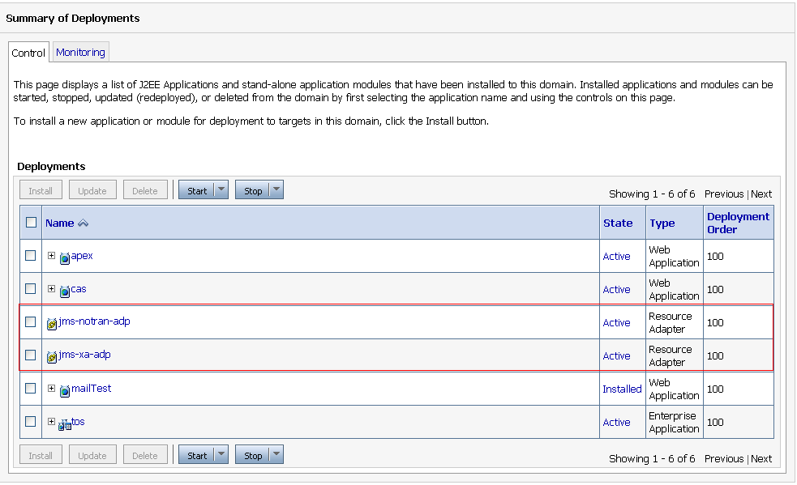
Create a persistent store on managed server 1, called “jms.store.tdp”:

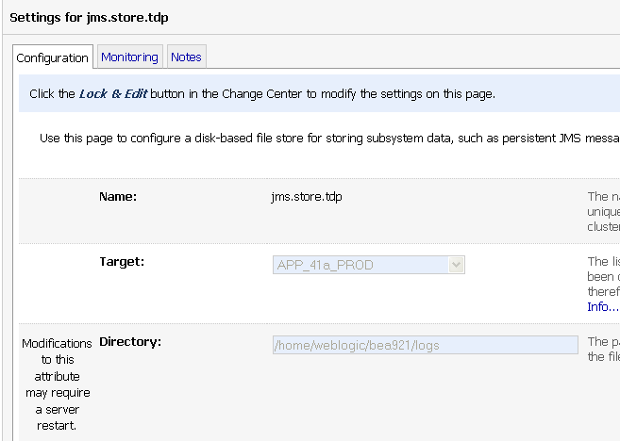

Create a JMS Server called “jms.server.tdp”, targeted to managed server 1 and using the “jms.store.tdp” store.
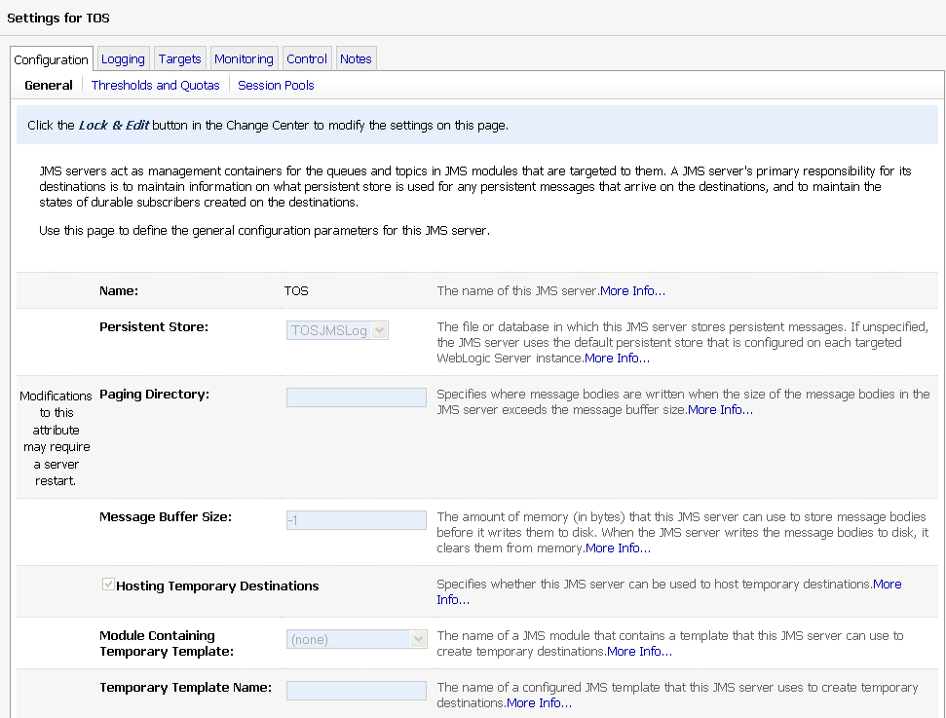
Create a JMS module, called “jms.module.tdp”. This module will contain a connection factory and 12 JMS queues (see table below to cut and paste).
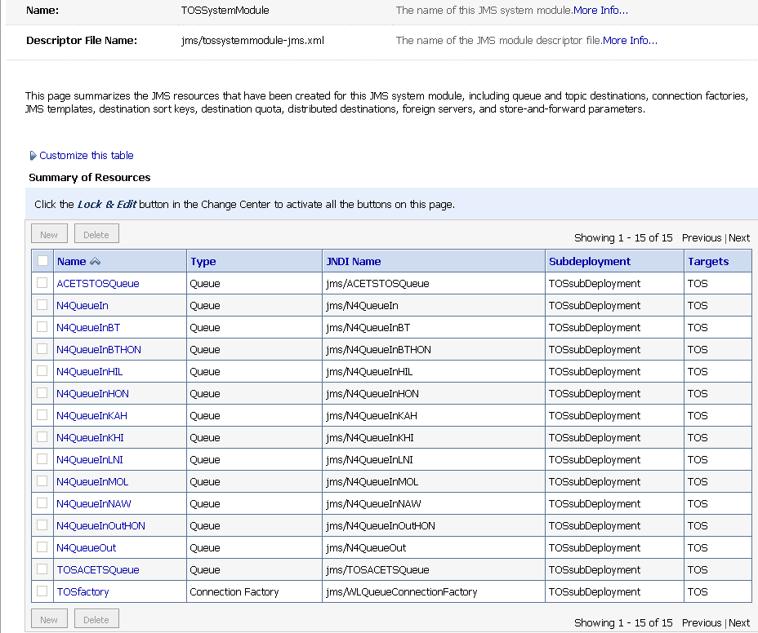

The setup for this module should include a new subdeployment called “TOSsubDeployment”.

Name | Type | JNDI Name
jms.conn.tdp.TOSfactory | Connection Factory | jms/WLQueueConnectionFactory
jms.queue.tdp.N4QueueIn | Queue | jms.queue.tdp.N4QueueIn
jms.queue.tdp.N4QueueInBT | Queue | jms.queue.tdp.N4QueueInBT
jms.queue.tdp.N4QueueInBTHON | Queue | jms.queue.tdp.N4QueueInBTHON
jms.queue.tdp.N4QueueInHIL | Queue | jms.queue.tdp.N4QueueInHIL
jms.queue.tdp.N4QueueInHON | Queue | jms.queue.tdp.N4QueueInHON
jms.queue.tdp.N4QueueInKAH | Queue | jms.queue.tdp.N4QueueInKAH
jms.queue.tdp.N4QueueInKHI | Queue | jms.queue.tdp.N4QueueInKHI
jms.queue.tdp.N4QueueInLNI | Queue | jms.queue.tdp.N4QueueInLNI
jms.queue.tdp.N4QueueInMOL | Queue | jms.queue.tdp.N4QueueInMOL
jms.queue.tdp.N4QueueInNAW | Queue | jms.queue.tdp.N4QueueInNAW
jms.queue.tdp.N4QueueInOutHON | Queue | jms.queue.tdp.N4QueueInOutHON
jms.queue.tdp.N4QueueOut | Queue | jms.queue.tdp.N4QueueOut
jms.topic.tdp.n4 | Topic | jms.topic.tdp.n4  DAS Subscriber - jms.bridge.tdp.to.das.n4  ClientId- MessagingBridge.jms.bridge.tdp.to.das.n4
jms.topic.tdp.newVesselHon | Topic | jms.topic.tdp.newVesselHon  DAS Subscriber - jms.bridge.tdp.to.das.nvi  ClientId- MessagingBridge.jms.bridge.tdp.to.das.nvi
gems.tos.n4.formatted | Queue | gems.tos.n4.formatted

- Application Start/Stop Instructions
See the appendix for details about XPS.
  - Weblogic
When the deployment artifact is copied to the deploy directory (EAR or WAR file), the permissions should include the executable attribute set to true.
N4
The deployment artifact for Navis N4 is called apex.war. This WAR is deployed to the cluster. The start up/shut down procedure must be to stop/start the WebLogic servers. The redeploy process does not work. The administration server is not required to be shutdown, but can be without harm. No special coordination with the external servers is required (e.g. XPS or Edge manager). However, after a restart, someone from the support team should verify that everything working.
When there is a release from Navis and the version number on the apex.war is incremented a more specific deployment process should follow.
1. WL Admin, un-install application apex.war
2. WL Admin, stop all WL servers (admin and two managed servers)
3. WL Admin, clear stage directory on both physical servers:
PhysicalServer1:/home/weblogic/bea921/user_projects/domains/MATSON/servers/ManagedServer1/stage/apex
PhysicalServer2:/home/weblogic/bea921/user_projects/domains/MATSON/servers/ ManagedServer2/stage/apex
4. WL Admin, copy new WAR file to TOS WLS Environment Servers (PhysicalServer1 & PhysicalServer2)
5. WL Admin, start the admin server and the first managed server
6. WL Admin, install (target the cluster) and deploy application apex.war
7. WL Admin, once the apex.war application is in ACTIVE state (this may take awhile), restart managed server 2

Tos Data Processor
The deployment artifact for the TOS Data Processor is called tos.ear. This application is deployed on 1 managed server in each environment [DEV= SVR1_A02_DEV, QA= APP_35a_QA, PP= APP_37a_PRE, PROD= APP_41a_PROD]. The application can be stopped and started from the Weblogic console at any time without any dependencies or special checkout required. The redeploy process does work for this application.

- Configuration Files
None – All configuration information for N4 and TOS Data Processor is kept in the database.
- Dependencies
As described in Section 4, Data Flow Diagram, the application has the following dependencies:
Dependency | Description | Modules
Mainframe | The mainframe sends ACETS and FACTS updates to N4 using MQ. If the communication between the application and MQ is disconnected for any reason messages should queue and be processed when the connection is restored.  The normal mainframe outage times are acceptable for availability SLA’s for TOS. Messages are coming from the Mainframe to TOS and not the other way. If the mainframe is down, then there are no pending transactions to be processed. | All
CMIS | N4 sends messages to CMIS for event notification and receives updates from CMIS for Vessel Schedule and New Vessel process. Tos Data Processor connects to a FTP server in Honolulu to send messages to CMIS. The FTP process uses CAS FTP. | ALL
EMAIL Server | Responsible for the transmission and delivery of N4 events.  The production SMTP server should have Tier I availability to support the TOS environment. | N4
Edge Manager | Edge Manager sends information from a trucks RFIDs and the gate scale to N4.  The availability for the edge manager is the same as N4 itself, Tier I. However, if the edge manager is unavailable, the work around is for the clerk to do manual data entry. This is acceptable for a number of hours. | N4
NOW | NOW sends position information from the EIT to XPS.  NOW availability is nearly 24x7 with no downtime. This product will give the terminal the required automation to work and plan the vessel and yard. Without it, the terminal will come to a standstill. | XPS
LXE | The LXEs are used in the yard to perform transactions that are sent to the XPS. | XPS
XPS | This is a set of servers on or near the terminal, one for each facility. This server is used by the SPARCS client and for vessel and yard automation. There is no direct dependency on XPS for N4. However, XPS will not be able to start up if N4 is not alive first. Also, XPS will need N4 to be alive to persist data. If during the N4 outage, XPS were to also crash data would be lost.  XPS availability is nearly 24x7 with no downtime. This product will give the terminal the required automation to work and plan the vessel and yard. Without it, the terminal will come to a standstill.  XPS requires N4 to be up to start. This is because XPS does not have a database, it uses the N4 database. However, it can survive an N4 outage because they both use coherence cache. Therefore, yes – it is true that XPS will not come up without N4 alive. However, it can stay up without N4. If XPS crashes while N4 is down, we must wait for N4 to be alive to continue. | N4
Oracle | The N4 application is dependent on the database. Specifically, APEX.WAR needs MATP03 and TOS.EAR needs MATP03 and MATP01. If there is an outage of just MATP01, TOS.EAR will continue to work, some FTP files will queue and be delivered once MATP01 returns. | N4, TDP

- Jobs, Schedule and Messages/Alerts
Job Name | Frequency / Timing | Success/Fail Message | Purpose
New Vessel | File created at each vessel sailing destined for the port of HON.  Checking for the presence of the file happens every 12 minutes. | If the TOS Data Processor is unable to parse the file from the FTP server, a failure email is sent to the SN4 support team.  If Navis N4 rejects a transaction, a failure email is sent to the SN4 support team. | A process in paradox collects inputs from various sources and creates a stow plan. This stow plan is input to Navis N4. After the stow plan is created in a comma separated value text file, it is stored on an FTP server locally in HON. The TOS Data Processor will pick up the file, manipulate the data and send it to Navis N4 via JMS. The CMIS process to create the stow plan happens every time a vessel sails destined for the port of HON. TOS Data Processor will look for the presence of this file every 12 minutes and send the updates to Navis N4 immediately.  At the end of the process, which is one day after sailing, the manifest is sent to the HDOA via web services for imports to Hawaii (not barges).  Timing: The manifest should arrive at the state 48 hours before arrival in Hawaii. This gives a normal sailing a 24 hour window to create and send the manifest.  Impact: The impact of delaying this process past vessel arrival means that availability notices could be delayed. The inspector must be scheduled and if the list of holds is delayed, the inspector might be late by a day.  Workaround: Today, Matson sends a hard copy report to the State. It is acceptable to use this process if the automated version is unable to complete.
All monitoring is done by the SN4 support team. No requirements from the operations team or CSC.
Late DCM | A west coast port may send an updated DCM file. If this happens it is emailed to the HON data integrity team.  The HON data integrity team will then manually upload the file to the TOS Data Processor through a web interface. The uploaded file is stored in the standard CSC FTP server.  TOS Data Processor will check for the presence of the file on the FTP server every 4 minutes. | If the TOS Data Processor is unable to parse the file from the FTP server, a failure email is sent to the SN4 support team.  If Navis N4 rejects a transaction, a failure email is sent to the SN4 support team. | If the west coast finds that they missed some hazardous reporting, they will email a new DCM file. The SN4 support team will put this file on the local HON FTP server. The TOS Data Processor will grab and parse this file from the HON FTP server. TDP will convert the text to XML and send the message to Navis N4 via JMS.
All monitoring is done by the SN4 support team. No requirements from the operations team or CSC.
Vessel Schedule | File created at each Fleet Scheduling System publish.  Checking for the presence of the file happens every 10 minutes. | If the TOS Data Processor is unable to parse the file from the FTP server, a failure email is sent to the SN4 support team.  If Navis N4 rejects a transaction, a failure email is sent to the SN4 support team. | Each time the Fleet Scheduling System performs a publish, a portion of the schedule is serialized and sent to an FTP server. This file is read by a paradox process that loads the necessary data into CMIS. The same CMIS process will then create a new file and store it on a local HON FTP server. The TOS Data Processor will read this file, change the format and send JMS messages to Navis N4.
All monitoring is done by the SN4 support team. No requirements from the operations team or CSC.
DCM from Navis N4 | File created at each vessel sailing from the port of HON.  The HON data integrity team will then manually upload the file to the TOS Data Processor through a web interface. The uploaded file is stored in the standard CSC FTP server.  TOS Data Processor will check for the presence of the file on the FTP server every 4 minutes. | If the TOS Data Processor is unable to parse the file from the FTP server, a failure email is sent to the SN4 support team.  If the destination FTP is unavailable, a failure email is sent to the SN4 support team.  If the process is unable to successfully send an email to the distribution list, an error is logged and another email is attempted to the SN4 support team. | When a vessel sails from the port of HON, a Navis N4 user runs a report that generates a dangerous cargo manifest file. This file is saved locally on the user machine. Then the user initiates a process that places the file on the common CSC standard FTP server. Every 4 minutes, the TOS Data Processor will look for this file. When found, it will grab the file, parse it, and send the results to an email distribution list, place a copy on a HONO FTP server and on the Tier II/III FTP server for the HAZMAT application to pick up.
All monitoring is done by the SN4 support team. No requirements from the operations team or CSC.
STIF to Navis N4 | File created at each vessel sailing destined for the port of HON and emailed to the SN4 support team.  The SN4 support team will then manually upload the file to the TOS Data Processor through a web interface. The uploaded file is stored in the standard CSC FTP server.  TOS Data Processor will check for the presence of the file on the FTP server every 4 minutes. | If the TOS Data Processor is unable to parse the file from the FTP server, a failure email is sent to the SN4 support team.  If Navis N4 rejects a transaction, a failure email is sent to the SN4 support team. | When a vessel sails destined for the port of HON, a STIF file is produced from the origin port and emailed to a number of recipients. The SN4 support team receives the email and moves the STIF file to the CSC standard FTP server.  The TOS Data Processor checks for the presence of this file on the CSC standard FTP server. When found, grabs the file and parses it, finally sending messages to Navis N4. These messages instruct Navis N4 to create new units that are inbound to the port.
All monitoring is done by the SN4 support team. No requirements from the operations team or CSC.
Navis N4 Events to CMIS Translator | JMS messages from Navis N4 are sent to the TOS Data Processor. TDP will collect this data, change the format and send the file to an FTP server.  The file is sent to the FTP server every 600 seconds or every 20 transactions, whichever comes first. | If the TOS Data Processor is unable to send the file to the FTP server, a failure email is sent to the SN4 support team. | As events occur in Navis N4, they are communicated to the TOS Data Processor using JMS. The TOS Data Processor will capture these XML messages coming via JMS and transform them into text files. The text files are then sent on to the CMIS translator via FTP to an FTP server in HON.
All monitoring is done by the SN4 support team. No requirements from the operations team or CSC.
ACETS/FACTS Mainframe updates to Navis N4. | These messages are sent in real time. The queue structure allows for messages to sit and build up if needed in the event that one system is down. | If the TOS Data Processor has any problems connecting to either the JMS queue or MQ, an email is sent to the SN4 support team. | Equipment and booking updates sourced at the mainframe are packaged up in MQ messages and sent to an MQ destination. The TOS Data Processor reads the messages from MQ, converts the message format and sends them to Navis N4 on a JMS queue.
All monitoring is done by the SN4 support team. No requirements from the operations team or CSC.
- Health Checks
  - The link below should return a login page. Replace the IP in the URL with the appropriate IP for the environment for which the health check is performed.
http://10.3.4.179/apex
  - Log in to the SPARCS N4 web user interface. Switch to “Administration”, the choose “System” and finally “Cluster Management”. The resulting tab should look similar to the screen below. One “N4” entry for each managed server in the WebLogic cluster. They should all read “ACTIVE.” The journal size should be zero.
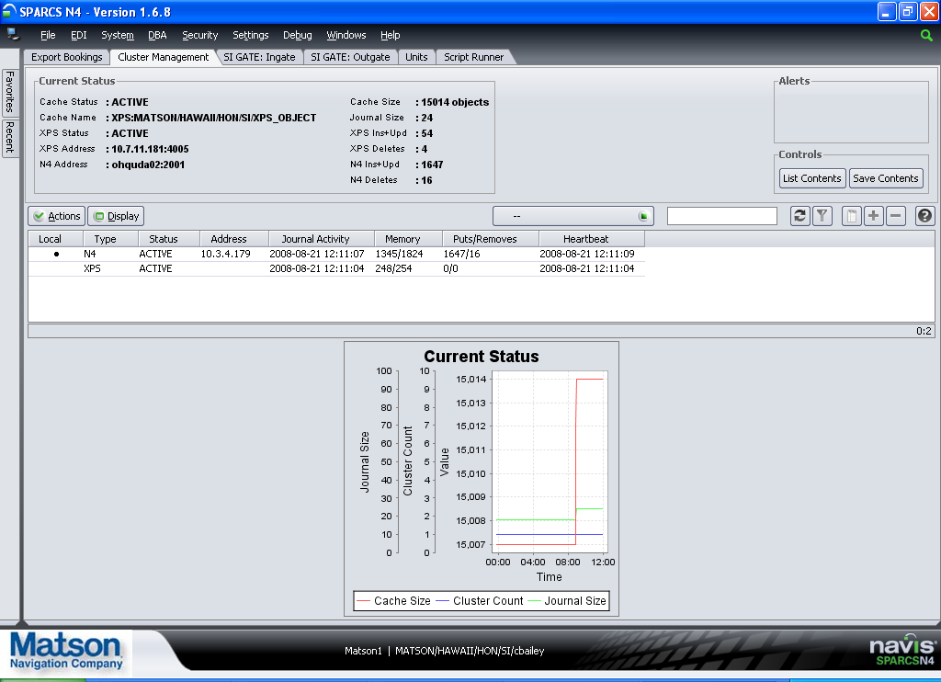
  - The SPARCS N4 thick client has box in the upper right corner that will flash red during a communication problem. Users may report a “flashing red status box.” Below is a screenshot of the SPARCS client. The box in the upper left corner is where the flashing red would take place.
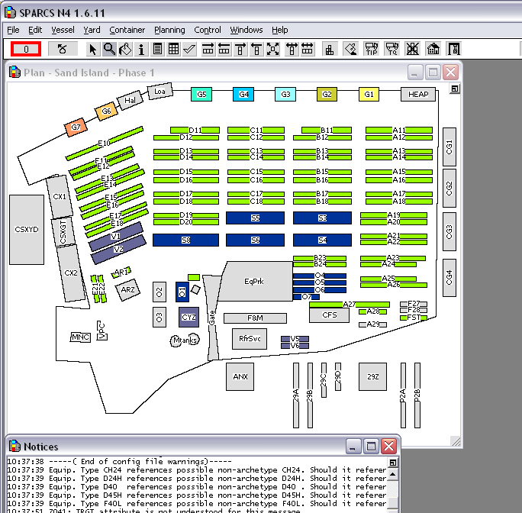
- Exception Handling
Log files created in the /home/logs/applogs/TOS and /home/logs/applogs/cas directories may contain exceptions. These exceptions need to be handled by the SN4 support team. No exceptions are expected.
For each failure, an email from the TOS Data Processor will be sent to the support team. Failures from Navis N4 are sent via JMS to the TOS Data Processor to allow for all emails to originate from the same place.

- Users
- Matson Navigation Company; Salt Lake City, Utah; Planners: Will use both the SPARCS N4 web client and the SPARCS N4 thick client.
- Matson Navigation Company; Phoenix, Arizona; Customer Service Representatives: Will use the SPARCS N4 web client.
- Matson Navigation Company; Honolulu, Hawaii; Terminal Operations: Will use both the SPARCS N4 web client and the SPARCS N4 thick client.
- Matson Terminals; Honolulu, Hawaii; Clerks; Will use the SPARCS N4 web client.
- Clients and Agents for Matson; Honolulu, Hawaii; Pacific Transport Lines, Maersk and Norton Lilly, etc.: Will use the SPARCS N4 web client.

The Honolulu Gate & Customer Support department; Customer service staff in Phoenix, Vessel Planners in Salt Lake City; and gate, F&M, container ops, process team, container yard, freight processing, claims, sales, and accounting in Honolulu are all users of the system.
User Acceptance Testing Participants – A sample of the users involved:
Tester | Role | UAT Location
Gail Anonsen | Subject Matter Export/UAT Lead | HON
Jocelyn Chagami | SPARCS Expert | HON
Linda Chong | Lead Tester – Gate, Customer Support, Container Yard | HON
Joanne Mahuka | Lead Tester – Gate, CS, CY | HON
Iwalani Maner | Tester – Gate, CS, CY | HON
Carol Hamasaki | Tester - Gate, CS, CY | HON
Cathy Kanehiro | Tester - Gate, CS, CY | HON
Mila Aglanao | Tester - Gate, CS, CY | HON
Greta Gainey | Tester - Gate, CS, CY | HON
Walter Harada  Michael Kikuta  Derwin Gealon  Ikaika Gueco | Tester – Process Team | HON
Elizabeth Turner Keiko Tanada  Jessica Bailey | Tester – Customer Svc | PNX
Robert Potter  Brian Robb | Tester – Vessel Planning | HON
Vern Ramie  Linda Takase  Kristi Moriyasu | Tester – Container Ops | HON
Judy Sakoda  Pearl Alonzo Oshita  Kent Takazawa | Tester - Accounting | HON
Kenneth Ocreto  Tisa Wilson | Tester - CVS | HON
Linda Oba | Tester – Auto Lot | HON
John Robinette | Tester - Claims | HON
Leimomi Tagawa  JoJo Kaea | Tester – F&M | HON
Dorothy Cooper | Tester – Freight Processing | HON
Paul McCully  Bryan Gomes | Tester - Sales | HON
Bill Pirtle  Letricia Linborg-Naehu  Didi Kapua | Tester – Pacific Transfer | HON
Mari Tani (Norton Lilly)  Julio Torres (Maersk) | Tester - Client | HON

- Alarming Requirements
Exceptions in the application will be visible in the application log files:
/home/logs/applogs/TOS/*-navis-apex.log
/home/logs/applogs/TOS/TosDataProcessor.log

Unexpected exceptions will be sent via email to the support group. The environment and WebLogic server are listed in the subject line. An example message follows:

From: 1SN4Supt@matson.com [mailto:1SN4Supt@matson.com]
Sent: Thursday, February 26, 2009 2:13 PM
To: 1SN4 Support at Matson
Subject: [APP_37A_PRE] ACETS Error Message

[Customer Groovy Code generated an exception: ERR_GVY_BDA_003. Unit: MATU2516157 Booking Num dismatch: N4 num=3625431 BDA num=8631306.]<?xml version="1.0" encoding="UTF-8"?><argo:snx xmlns:argo="http://www.navis.com/argo" xmlns:xsi="http://www.w3.org/2001/XMLSchema-instance" xsi:schemaLocation="http://www.navis.com/argo snx.xsd"><groovy class-location="database" class-name="GvyInjAbda"><parameters><parameter id="recorder" value="$SDEV41" /><parameter id="sealNum" value="610914" /><parameter id="commodity" value="NEW MACHINERY" /><parameter id="vesvoy" value="RJP339" /><parameter id="consigneeName" value="ROYAL HAWAIIAN MOVERS INC" /><parameter id="shipperId" value="0017006310" /><parameter id="equipment-id" value="MATU2516157" /><parameter id="temp" value="" /><parameter id="shipperName" value="APPROVED FORWARDERS OF HAWAII" /><parameter id="bookingNum" value="8631306" /><parameter id="destPort" value="HON" /><parameter id="loadPort" value="LAX" /><parameter id="dischargePort" value="HON" /><parameter id="consigneeId" value="0000008812" /></parameters></groovy></argo:snx>

Process/Job Name
System | WebLogic, Oracle
Error Log | /home/logs/applogs/TOS/*-navis-apex.log  /home/logs/applogs/TOS/TosDataProcessor.log
Log Message | Java Exceptions
Description
Action | Support team to address after email is received. Some discretion as to urgency can be deemed from the particular message.
Additional Notes

  - Process Name
WebLogic and deployments within WebLogic – looking for any Java Exceptions as well as memory and CPU constraints.

  - System

WebLogic

Development
ohquda02 - 10.3.4.179
DEV Console
N4 Console Client

QA
matcamuqa35 - 10.201.0.14
QA Console

PreProduction
matcvauaa37 - 10.201.2.27
matcvauaa38 - 10.201.2.29
PreProd Console

Production
matcamupa41 - 10.201.1.18
matcamupa42 - 10.201.1.21
Production Console

Database
- DEV, OHQUDD02 (10.3.4.180)
- QA, MATUQD09 (10.201.1.8)
- PRE, MATCVAUAD50 (10.201.2.56)

PreProd backup db - MATCVAUAD51(10.201.2.48)
- Production, MATCAMUPD48 (10.201.1.33)

Prod backup db-MATCAMUPD49(10.201.1.32)

  - Error Log
/home/logs/applogs/TOS/*-navis-apex.log
/home/logs/applogs/TOS/TosDataProcessor.log

  - Log Message
An example exception in the log file follows:
2008-09-11 18:05:53,655 ERROR [[ACTIVE] ExecuteThread: '1' for queue: 'weblogic.kernel.Default (self-tuning)'] [Message
CollectorImpl:87] ( ) UNCAUGHT EXCEPTION: class java.lang.NullPointerException: null
java.lang.NullPointerException (compact stack trace follows)
com.navis.road.business.model.CachedScanKey.getXpsCacheKey(CachedScanKey.java:37)
com.navis.road.business.model.CachedScan.store(CachedScan.java:103)
com.navis.road.business.apihandler.BaseScanHandler.storeScan(BaseScanHandler.java:358)
com.navis.road.business.apihandler.BaseScanHandler.storeScan(BaseScanHandler.java:349)
com.navis.road.business.apihandler.BaseScanHandler.storeScans(BaseScanHandler.java:133)
com.navis.road.business.apihandler.RecordScanHandler.execute(RecordScanHandler.java:43)
com.navis.road.webservice.GateWebservice.processUpdate(GateWebservice.java:75)
com.navis.argo.webservice.ArgoWebServices$1.doInTransaction(ArgoWebServices.java:260)
com.navis.framework.persistence.hibernate.PersistenceTemplate.invoke(PersistenceTemplate.java:114)
com.navis.argo.webservice.ArgoWebServices.genericInvoke(ArgoWebServices.java:256)
com.navis.argo.webservice.ArgoWebServices.genericInvoke(ArgoWebServices.java:71)
java.lang.NullPointerException
at com.navis.road.business.model.CachedScanKey.getXpsCacheKey(CachedScanKey.java:37)
at com.navis.road.business.model.CachedScan.store(CachedScan.java:103)
at com.navis.road.business.apihandler.BaseScanHandler.storeScan(BaseScanHandler.java:358)
at com.navis.road.business.apihandler.BaseScanHandler.storeScan(BaseScanHandler.java:349)
at com.navis.road.business.apihandler.BaseScanHandler.storeScans(BaseScanHandler.java:133)
at com.navis.road.business.apihandler.RecordScanHandler.execute(RecordScanHandler.java:43)

  - Description
These error messages are delivered to the SN4 support team via email and must be addressed on a case-by-case basis to determine details.

  - Action
- All exceptions are first triaged by the support team before the operations team is required.

  - Additional Notes

Functional SLA’s
A number of business functions that will be preformed by this solution have performance requirements.

Gate Functions:
- RFID scans and the scale reads should appear on the gate screen by the time the truck arrives at the window.
- The time the trucker spends at the gate working with the clerk should remain unchanged from the CMIS processing of today. This is variable based on the transaction type (receive empty, receive export, dray in, etc.).
- Container Movement Clerks frequently used screens should have sub-second response:
- Lookup a container
- History
- Release container to second trucker
- Add Hold
- Release Hold
- Printing at the gate should be instantaneous.

NOW:
- Position updates from NOW should appear in N4 < 2 seconds
- EIT Updates should be posted to NOW < 5 seconds

SPARCS:
- Planners open a vessel, using the SPARCS client < 7 minutes. Today there is a workaround: remote desktop into the terminal server. This workaround will be available in the new solution as well.

Vessel Ops:
- LXE transactions should post to XPS < 5 seconds

Interfaces:
- FSS publish to N4 < 10 minutes
- The new vessel process from CMIS to N4 < 15 minutes
- VST sail flag sent from N4 to ACETS (through CMIS) < 5 minutes
- HDOA needs the manifest one day prior to arrival in HON (process SLA)

Disaster Recovery
- XPS part of the TOS environment should be available during the DR Test window.
N4 Disaster scenario | Expected result based on current architecture | Desired Result
1. A member of the WebLogic cluster goes down and another member survives. | At least one member of the cache cluster survives. XPS and N4 can still communicate. No interruption to XPS. | Same as expected. If the first managed server is the one that went down, restarting the mule (button inside in N4 client) is necessary by the development team. Restart procedure is documented here.
2. An outage at CSC in Cambridge. | XPS will stay alive, but without communication to N4. Transactions are allowed in XPS and queue up in the bridge extend. Once N4 is restored transactions recorded in XPS are sent from the bridge extend to N4 and persisted to the database. | Same as expected for a reasonably long outage.
3. A partial outage at CSC in Cambridge pulls down all WebLogic servers. (Add in normal software maintenance for WebLogic and Solaris, etc.) | XPS will stay alive, but without communication to N4. Transactions are allowed in XPS and queue up in the bridge extend. Once N4 is restored transactions recorded in XPS are sent from the bridge extend to N4 and persisted to the database. | Same as expected for a reasonably long outage.
4. A partial outage at CSC in Cambridge pulls down the Oracle database. | XPS and N4 will both stay alive. N4 will lose communication to the database. N4 will stay alive but throw persistence errors. N4 client users will not be able to continue working. Transactions are allowed in XPS. These transactions will be sent to N4 and sit and wait in the coherence cache. When the database returns, transactions from XPS queued up will be replayed in order. | Same as expected.
5. A network interruption between Hawaii and CSC. | XPS will queue up transactions and replay them to N4 when connection is restored. | Same as expected for a reasonably long outage.
6. COMBO: In the scenarios above that require the bridge extend to queue transactions (2, 3, and 5), the XPS server crashes. | XPS transactions queued up in the bridge extend will be lost. | We would like to see these XPS transactions that are queued in the bridge extend to be persisted to local disk or similar. When the XPS server is restored, read the transactions from the persistent store and replay them to N4. Until we have this fix from Navis, the data must be re-entered by the users for all lost data.
* Our testing reveals that a reasonably long outage is greater than 8 hours. We have not reached an upper limit on time yet, during testing.

XPS Disaster scenario | Expected result based on current architecture | Desired Result
The facility XPS server crashes. | Changes in N4 will be saved and delivered to XPS when it returns. | Same as expected.
The facility XPS server crashes and cannot recover. Switch to the XPS backup server. | Changes in N4 will be saved and delivered to XPS when it returns. | Same as expected.

- DASD Purge
N4 archives automatically. TDP does not save transactional data.

- List of All Data Files and Their Definitions
All data is stored in the database. Data integration is passed through JMS messages or via FTP. These files/messages hold transactional data and are deleted once processed. See sections above for more details on specific files, folders, and FTP details.
- Maintenance Windows
Day | Time Frame | Description
Tuesday | 9 PM MST (Phoenix) | Normal CSC deployment window.
Sunday | 11 AM MST (Phoenix) | Normal CSC deployment window.
Sunday | 0200 – 1300 PST | Normal MF maintenance window.

The TOS Data Processor deployments can occur during any normal maintenance window without the need for any user coordination. The Navis N4 deployments must be coordinated with the HON terminal to limit down time to the gate operations. After stabilization we expect these deployments to be very limited (around two per year).
During a maintenance window that would include MATP01, all jobs continue to run as normal without interruption with the exception of some FTP files that may be delayed.; however, the recovery is automatic. Simply notifying CMIS that events will not flow for sometime is enough.

- Reports/Output
16 reports are user requested in real time. These can be found in the N4 application on the reports tab. Automated output follows:
Name | Frequency | Description
Cargo Manifest Email | As needed. | As cargo status is updated or changed, an automatic email is sent to alert employees of the changes.

- Support Escalation Process and Contact Details
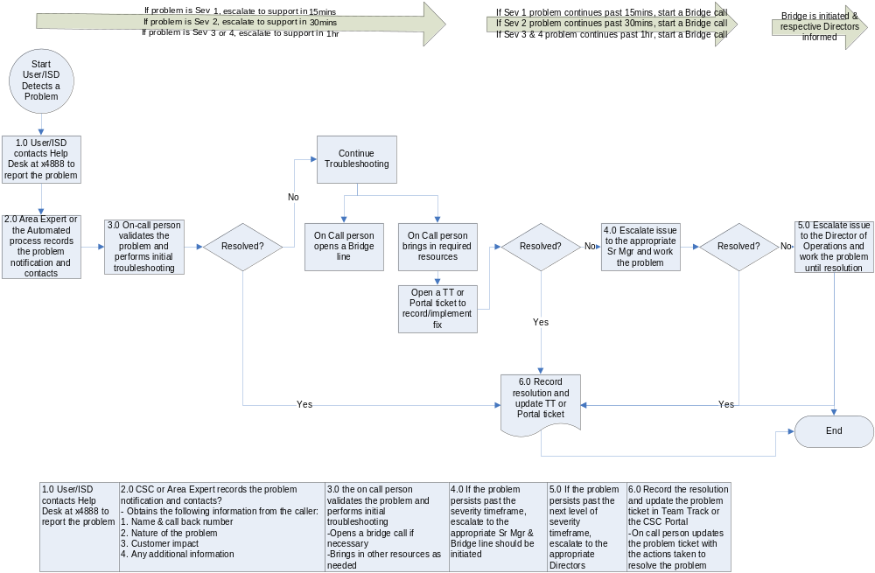

Contact Details
Level | Name | 1° Number | 2°Number | Email | Time Zone | Notes
1 | SN4 Support Team | X8368 |  | 1SN4 Support at Matson | HST | Honolulu support team – currently supporting CMIS.
2 | Steve Bauer | X5274 |  | sbauer@matson.com | MST | Development Team Lead
3 | Marwan Aiche | X5258 | 480-239-5122 | maiche@matson.com | MST | Development Team Manager

The support team phone number (x8368) automatically rolls between support team members, from cell phone to cell phone. The secondary levels should be used in emergency cases only.

- Post Production Monitoring and Metrics
No planned performance monitoring; may be requested and added as needed – see the architecture specification document for a list of SLA’s for parts of this application.

- Manual Test Procedures
The test procedure is documented and stored here:
\\mnc03p0s\Isd$\ITServices\_EnterpriseProjects\Terminals\Release2 TOS\2_Requirements\Gate Scenarios\D7 3UATScripts_Outgate_Gate_week 3.xls

- Roles and Responsibilities

 | IT Ops | DBA | ESS | SN4 Support Team
Web Server | P
Application Server | P
Oracle |  | P
Client Machines (Internet Explorer, Java, SPARCS Clients) |  |  | P
XPS Server |  |  | S | P
XPS Clients |  |  | S | P
Edge Manager |  | S | S | P
NOW Server |  |  | S | P
LXE |  |  |  | P
EIT |  |  |  | P
RFID Readers |  |  | P
Weight Scale |  |  | P

- Appendix
  - XPS Server Setup
XPS Server Install and Startup
http://wiki.matson.com/index.php?title=XPS_Upgrade

